**SQL CODING CHALLENGE**

**CAR RENTAL SYSTEM**

1. **CREATING TABLES**

CREATE TABLE Vehicle (

vehicleID INT PRIMARY KEY,

make VARCHAR(255),

model VARCHAR(255),

year INT,

dailyRate DECIMAL(10, 2),

status VARCHAR(20),

passengerCapacity INT,

engineCapacity DECIMAL(4, 2)

);

CREATE TABLE Customer (

customerID INT PRIMARY KEY,

firstName VARCHAR(255),

lastName VARCHAR(255),

email VARCHAR(255),

phoneNumber VARCHAR(20)

);

CREATE TABLE Lease (

leaseID INT PRIMARY KEY,

vehicleID INT,

customerID INT,

startDate DATE,

endDate DATE,

type VARCHAR(20),

FOREIGN KEY (vehicleID) REFERENCES Vehicle(vehicleID),

FOREIGN KEY (customerID) REFERENCES Customer(customerID)

);

CREATE TABLE Payment (

paymentID INT PRIMARY KEY,

leaseID INT,

paymentDate DATE,

amount DECIMAL(10, 2),

FOREIGN KEY (leaseID) REFERENCES Lease(leaseID)

);

**II.INSERTING VALUES**

INSERT INTO Vehicle (vehicleID, make, model, year, dailyRate, status, passengerCapacity, engineCapacity) VALUES

(1, 'Maruti Suzuki', 'Swift', 2022, 1500.00, 'available', 5, 1.2),

(2, 'Hyundai', 'Creta', 2023, 2200.00, 'notAvailable', 5, 1.5),

(3, 'Mahindra', 'Scorpio', 2021, 2000.00, 'available', 7, 2.2),

(4, 'Tata', 'Nexon', 2024, 1800.00, 'available', 5, 1.2),

(5, 'Honda', 'City', 2023, 1900.00, 'notAvailable', 5, 1.5);

INSERT INTO Customer (customerID, firstName, lastName, email, phoneNumber) VALUES

(101, 'Priya', 'Sharma', 'priya.sharma@email.com', '9876543210'),

(102, 'Rahul', 'Verma', 'rahul.verma@email.com', '8765432109'),

(103, 'Sneha', 'Gupta', 'sneha.gupta@email.com', '7654321098'),

(104, 'Amit', 'Singh', 'amit.singh@email.com', '9988776655'),

(105, 'Kavita', 'Joshi', 'kavita.joshi@email.com', '8877665544');

INSERT INTO Lease (leaseID, vehicleID, customerID, startDate, endDate, type) VALUES

(201, 1, 101, '2025-04-05', '2025-04-10', 'DailyLease'),

(202, 2, 102, '2025-04-08', '2025-04-15', 'DailyLease'),

(203, 3, 103, '2025-04-12', '2025-05-12', 'MonthlyLease'),

(204, 4, 104, '2025-04-15', '2025-04-22', 'DailyLease'),

(205, 5, 105, '2025-04-20', '2025-05-20', 'MonthlyLease');

INSERT INTO Payment (paymentID, leaseID, paymentDate, amount) VALUES

(301, 201, '2025-04-05', 7500.00),

(302, 202, '2025-04-08', 15400.00),

(303, 203, '2025-04-12', 60000.00),

(304, 204, '2025-04-15', 12600.00),

(305, 205, '2025-04-20', 57000.00);

1. **Update the daily rate for a Mercedes car to 68.**

SET SQL_SAFE_UPDATES=0;

UPDATE Vehicle

SET dailyRate = 68.00

WHERE make = 'Mercedes';

SET SQL_SAFE_UPDATES=1;

**2. Delete a specific customer and all associated leases and payments.**

DELETE FROM Payment

WHERE leaseID IN (SELECT leaseID FROM Lease WHERE customerID = 102);

DELETE FROM Lease

WHERE customerID = 102;

DELETE FROM Customer

WHERE customerID = 102;

**3. Rename the "paymentDate" column in the Payment table to "transactionDate".**

ALTER TABLE Payment

RENAME COLUMN paymentDate TO transactionDate;

**4. Find a specific customer by email.**

SELECT *

FROM Customer

WHERE email = 'priya.sharma@email.com';

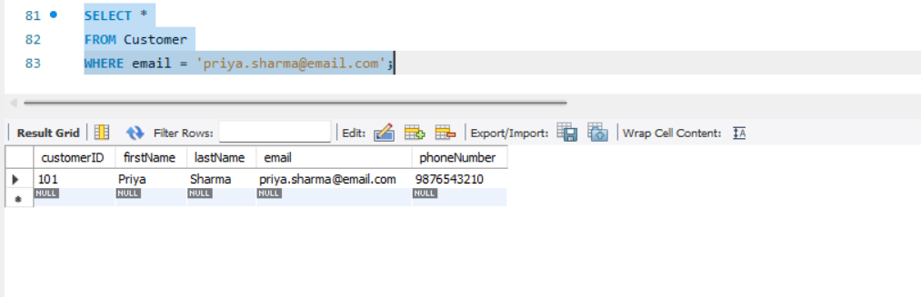

**5. Get active leases for a specific customer.**

SELECT *

FROM Lease

WHERE customerID = 101

AND endDate >= CURRENT_DATE;

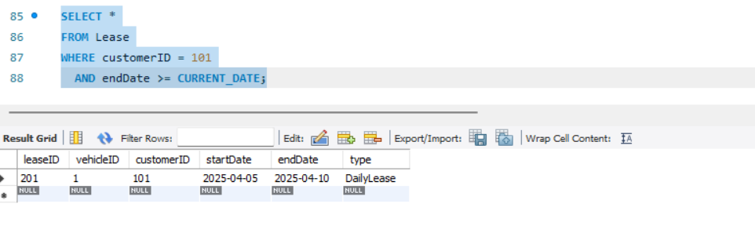

**6. Find all payments made by a customer with a specific phone number.**

SELECT p.*

FROM Payment p

JOIN Lease l ON p.leaseID = l.leaseID

JOIN Customer c ON l.customerID = c.customerID

WHERE c.phoneNumber = '9876543210';  
  
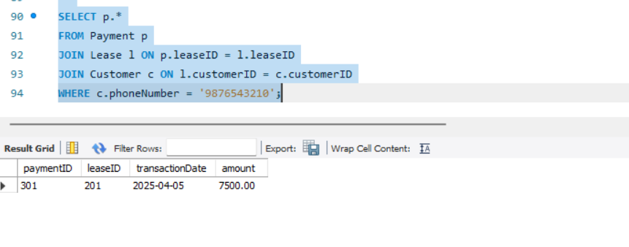

**7. Calculate the average daily rate of all available cars.**

SELECT AVG(dailyRate) AS averageDailyRate

FROM Vehicle

WHERE status = 'available';

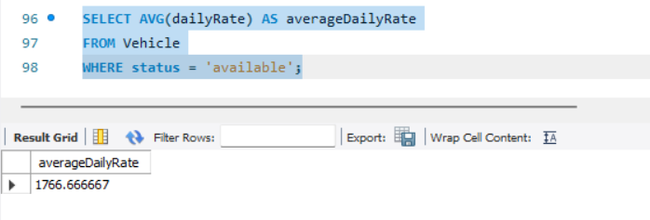

**8. Find the car with the highest daily rate.**

SELECT *

FROM Vehicle

ORDER BY dailyRate DESC

LIMIT 1;

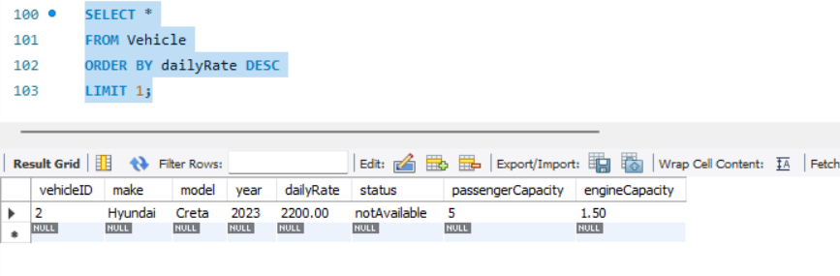

**9. Retrieve all cars leased by a specific customer.**SELECT v.*

FROM Vehicle v

JOIN Lease l ON v.vehicleID = l.vehicleID

WHERE l.customerID = 103;  
  
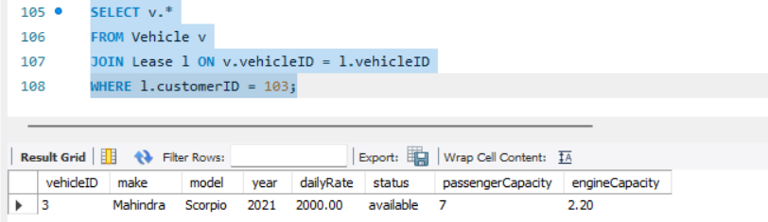

**10. Find the details of the most recent lease.**

SELECT *

FROM Lease

ORDER BY startDate DESC

LIMIT 1;

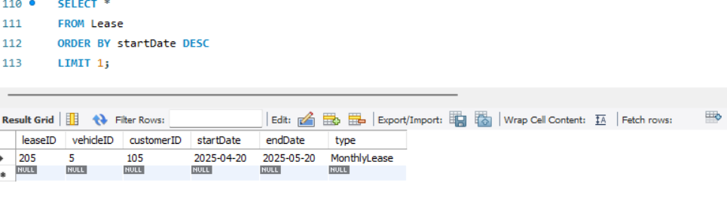

**11. List all payments made in the year 2023.**

SELECT * FROM Payment

WHERE YEAR(transactionDate) = 2023;

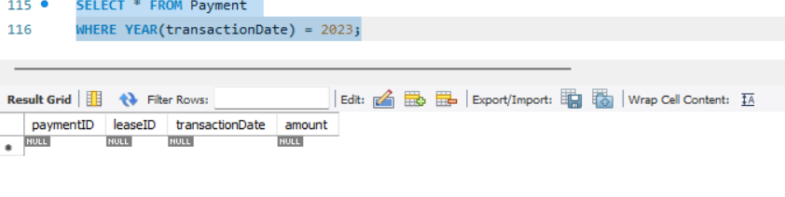

**12. Retrieve customers who have not made any payments.**

SELECT c.*

FROM Customer c

LEFT JOIN Lease l ON c.customerID = l.customerID

LEFT JOIN Payment p ON l.leaseID = p.leaseID

WHERE p.paymentID IS NULL;

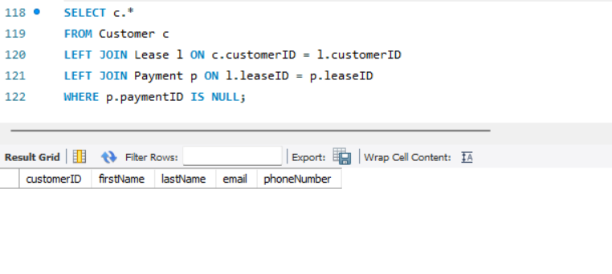

**13. Retrieve Car Details and Their Total Payments.**

SELECT v.make, v.model, SUM(p.amount) AS totalPayments

FROM Vehicle v

JOIN Lease l ON v.vehicleID = l.vehicleID

JOIN Payment p ON l.leaseID = p.leaseID

GROUP BY v.vehicleID, v.make, v.model;  
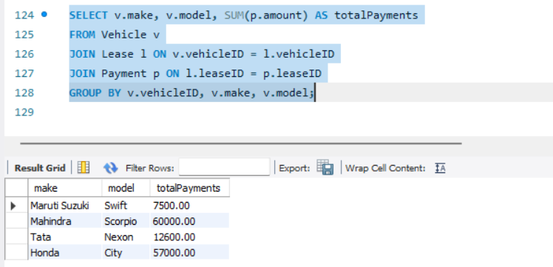

**14. Calculate Total Payments for Each Customer.**SELECT c.firstName, c.lastName, SUM(p.amount) AS totalPayments

FROM Customer c

JOIN Lease l ON c.customerID = l.customerID

JOIN Payment p ON l.leaseID = p.leaseID

GROUP BY c.customerID, c.firstName, c.lastName;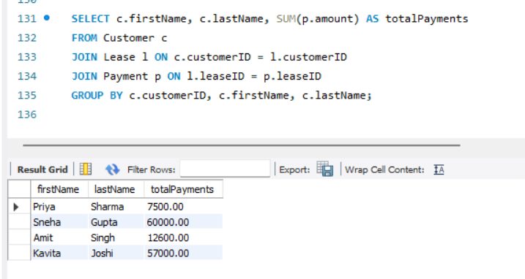

**15. List Car Details for Each Lease.**

SELECT l.leaseID, v.make, v.model, l.startDate, l.endDate

FROM Lease l

JOIN Vehicle v ON l.vehicleID = v.vehicleID;  
  
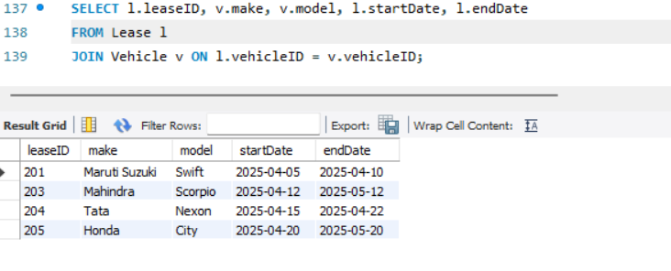

**16. Retrieve Details of Active Leases with Customer and Car Information.**

SELECT l.leaseID, c.firstName, c.lastName, v.make, v.model, l.startDate, l.endDate

FROM Lease l

JOIN Customer c ON l.customerID = c.customerID

JOIN Vehicle v ON l.vehicleID = v.vehicleID

WHERE l.endDate >= CURRENT_DATE;

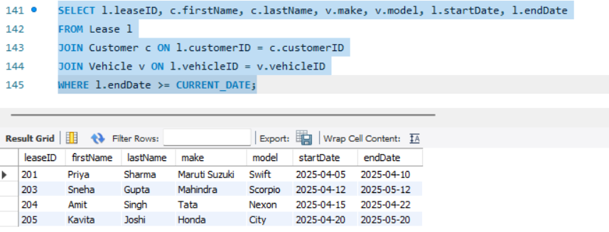

**17. Find the Customer Who Has Spent the Most on Leases.**

SELECT c.firstName, c.lastName, SUM(p.amount) AS totalSpent

FROM Customer c

JOIN Lease l ON c.customerID = l.customerID

JOIN Payment p ON l.leaseID = p.leaseID

GROUP BY c.customerID, c.firstName, c.lastName

ORDER BY totalSpent DESC

LIMIT 1;  
  
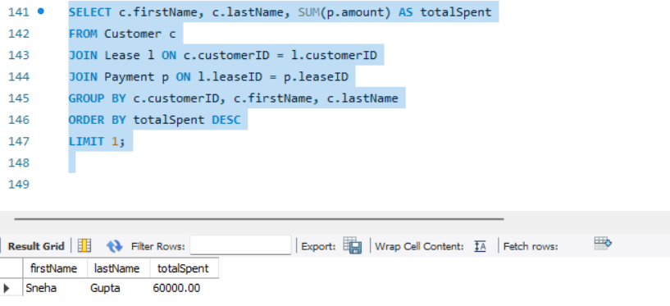

**18. List All Cars with Their Current Lease Information.**  
SELECT v.vehicleID, v.make, v.model, l.leaseID, l.startDate, l.endDate, c.firstName, c.lastName

FROM Vehicle v

LEFT JOIN Lease l ON v.vehicleID = l.vehicleID AND l.endDate  
  
